

Schaff, Cameron @CCNP&CYBERSECURITY
Soho Configuration For a PA220 Pan OS (10.2.6)
Cameron Schaff
CCNP IN PROGRESS -_-

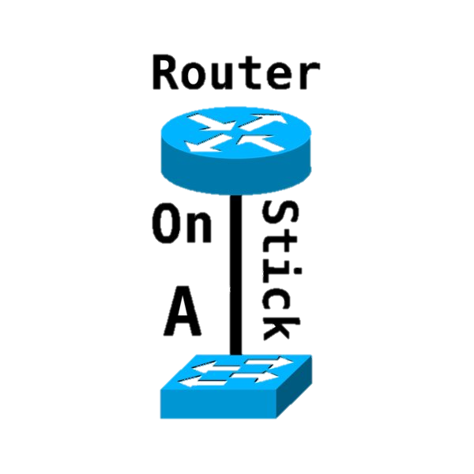
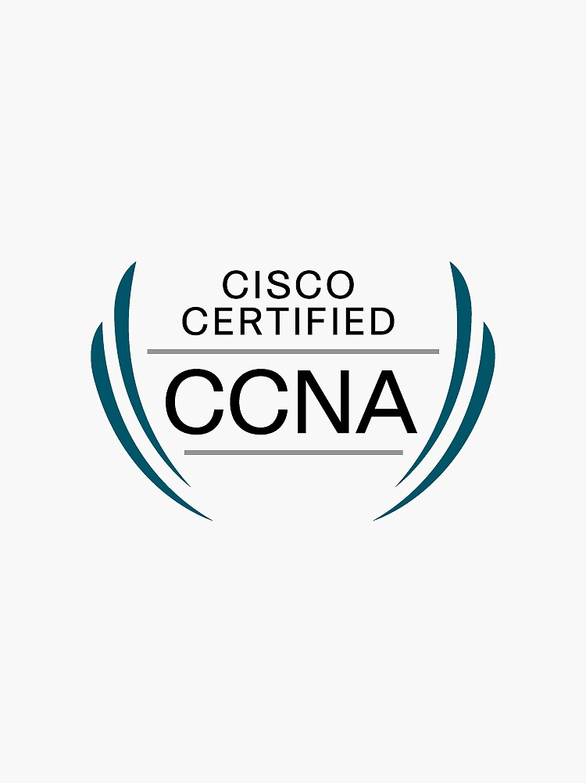
Cybersecurity Lab Report 2: Soho Initial configuration of PA-220
Purpose
Initial configuration to grant normal status for use on a home network connected to the internet.

Background Information on lab concepts
Concept: Understand the GUI of palo alto
Concept: Configuration by GUI
Background:
Features of the PA220
- Machine learning enhanced protection.
Through machine leaning and algorithmic protection we can prevent new spoofing and phishing attacks without need to update the OS version allowing for greater security within your network
- Full layer 7 inspection with categorization of apps ports 24/7
- Adaptive policy capable to conform to user activity, capable of grouping outside of Ip addresses and other common grouping methods.
- Encrypts traffic inbound and outbound on TLS 1.3 and HTTP/2
- Single pass packet processing unique to palo alto.
Policy lookup decoding and threat content is scanned in one pass to reduce consumption and overhead with only one device.

Compared to cisco firewalls that are expensive and hard to use even for experts. Palo alto aims to gain popularity for ease of use makes waves in the early stages of learning for beginning cyber experts.

Lab Summary
Use (Show system info) to get the Ip.
Use Ip to set your own Ip on same network.
Once done you can type the ip into the search bar of your browser in the format HTTPS.
Configure Firewall for security
Configure for DHCP Incoming and outcoming
Full Guide:
Assuming that you have access to the firewall from the last lab and you factory reset it. You should use Admin user and Admin Password for default log on or use your pre-designated sign in for the next steps.
Gain primitive access to the Firewall by console through Putty. (console program) 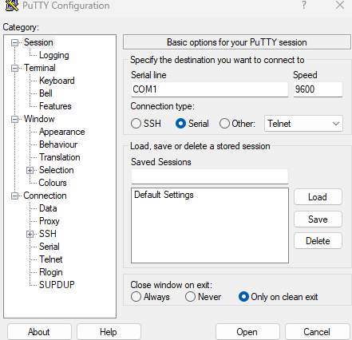
It should look something like this after you press open on your open com. If its blank then press enter and wait ~ one minute. If not than check your console connection and verify the cord integrity.
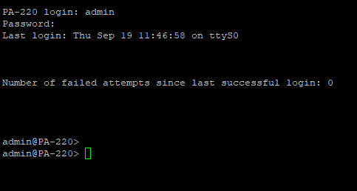
Using the Show System Info Command in the console line you can find your default or currently configured IP along with other info like subnet class and netmask,
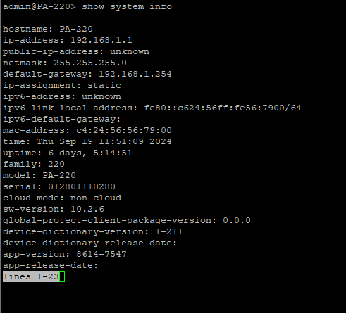
Once you find what network you need to be on to access the Web Gui, go find your “Ethernet Settings” in your windows search.
This will take you to your windows 11 Settings page or in windows 10 a different screen where you change IP’s through “properties”.
In that case select

I have Windows 11, so this is what mine looks like. 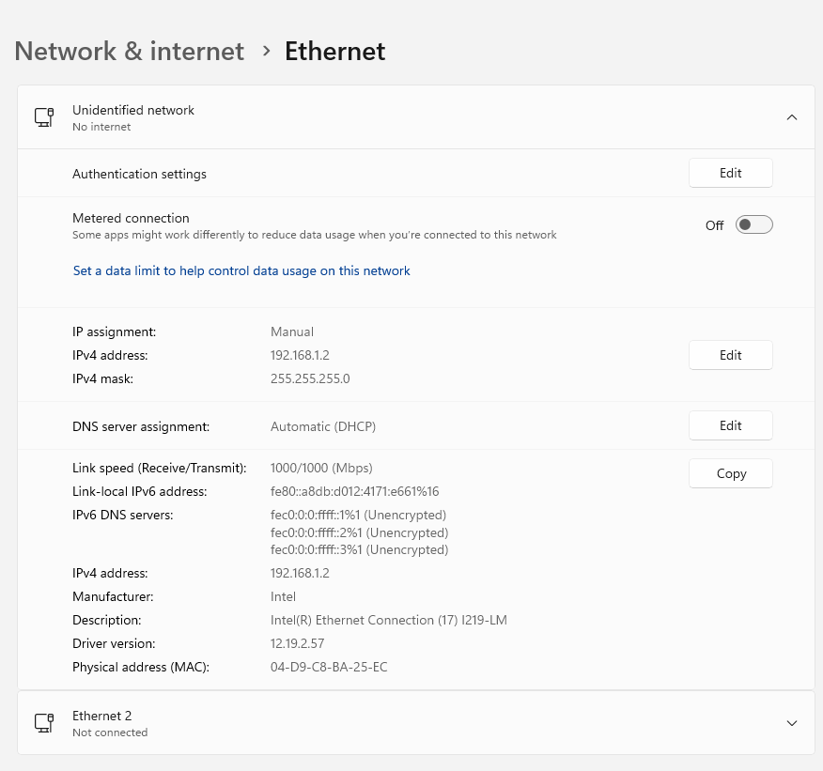
To change a configuration manually (we haven’t set auto up yet) set it to a useable Ip like 192.168.1.2 using the edit button.
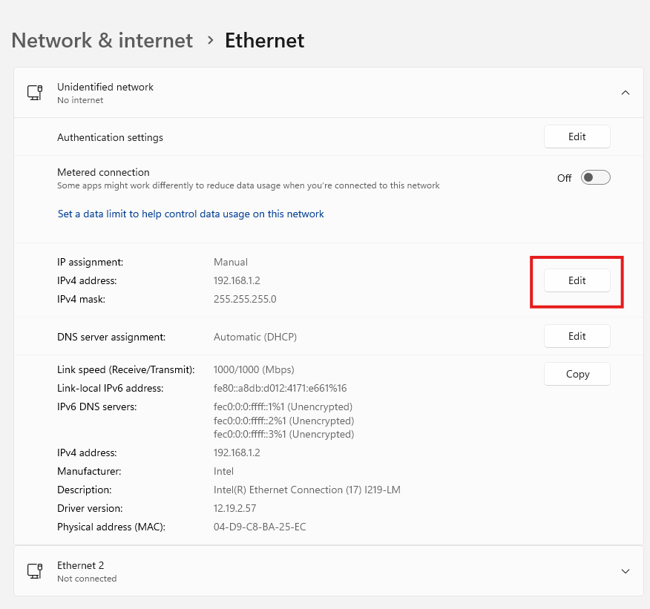

Clicking the edit button will result in this menu, click on the word DHCP, and set it to manual or if you are already set to manual skip this step. 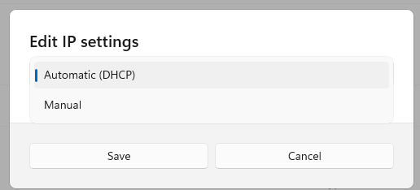

When you select manual, it will open a plethora of options. All you need to do though is set both the IP address and the Subnet mask to the ones shown in your earlier, Show systems command. After its changed it should look like this. Leave the other settings as blank or off. 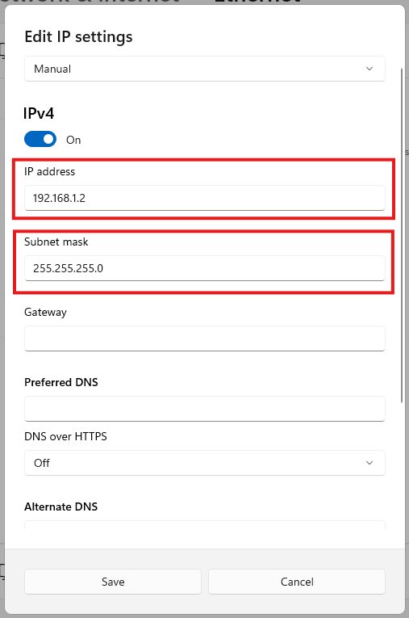
Clicking save will confirm the changes, if it doesn’t just config it again and try to save it again. Technology isn’t perfect either.
Now that you can access the same network as the firewall, make sure that you are ethernet connected with a normal ethernet cable into the
management port of the firewall, the other ports wont work for GUI access unless you set that up.
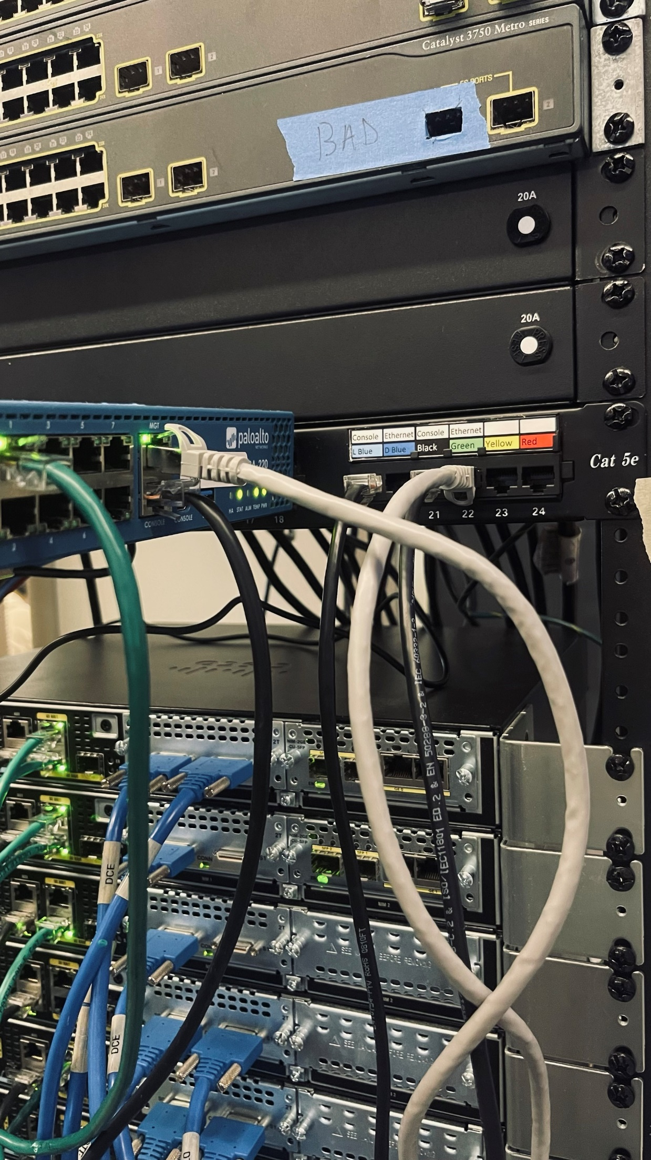
Ethernet connection from MGT to Ethernet on PC
Now using whatever browser you have, google, Firefox, etc.
Enter HTTPS://192.168.1.1 into your search bar.
If successful you should get a message like this. 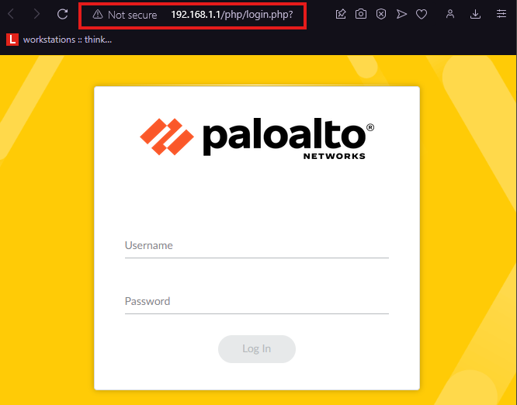
If you get a, “this site is trying to steal your identity” just click read or more info and then proceed to go to the website.

Login to palo alto with the username Admin and whatever password you set, or if you didn’t set one, use admin. (default setting)
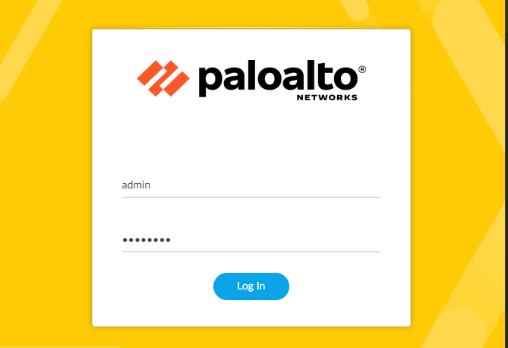
Create Security Zones
Go to: Network > Zones and click Add.
Create 3 zones:
- Untrust-L3, Type Layer3
- Trust-L3, Type Layer3
- Trust-L2, Type Layer2

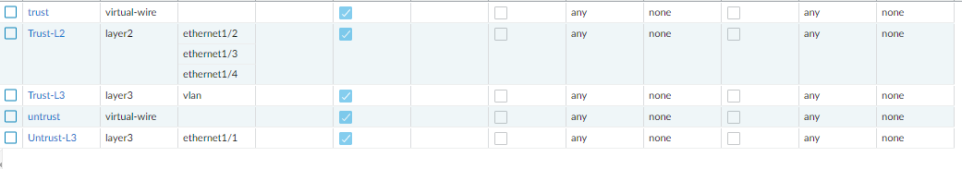
Here’s the steps to set up trusted and untrusted zones.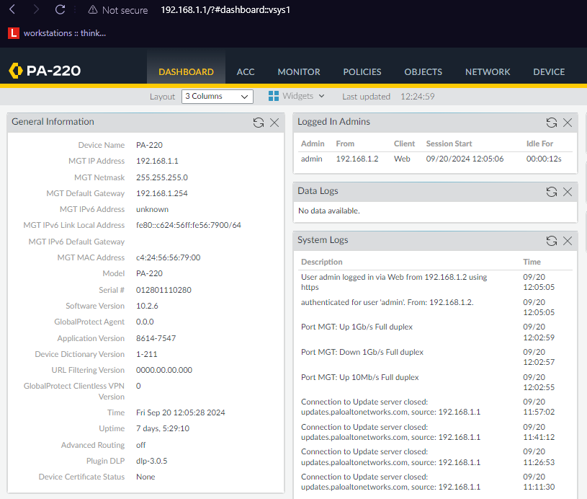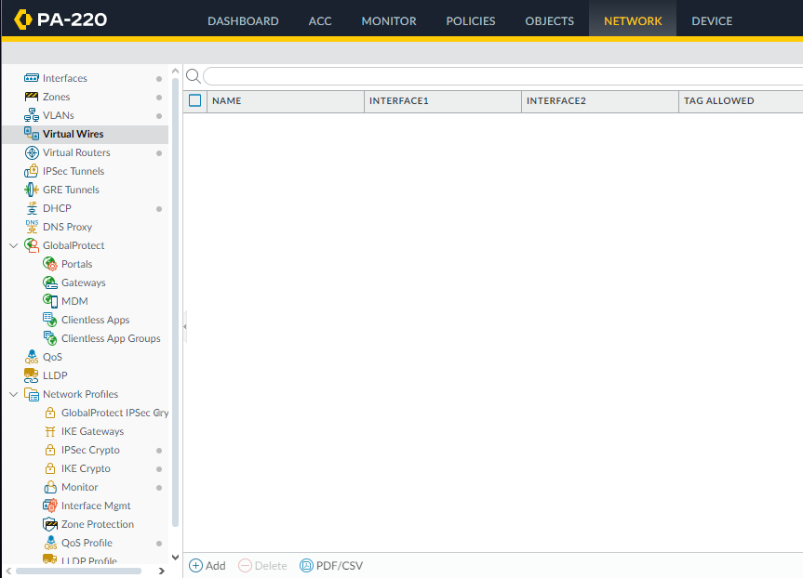

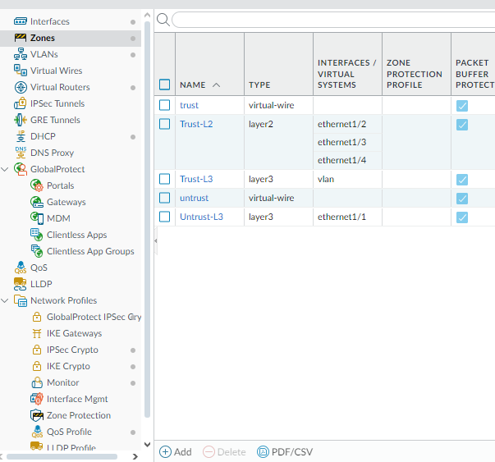

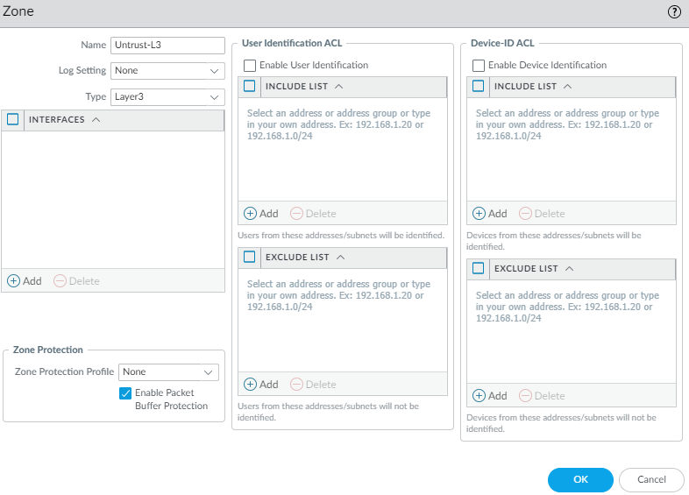
Repeat for Trust layer 3 Trust
For configuring Layer 2 Trust do this:
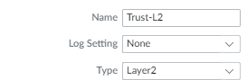
You should end with a list like this.

This is where that internet connection to your wall comes in, I recommend using ethernet 1/1 like me.
Start by going to the Network tab up top. (same tab as previous step)
And navigate to Interfaces.
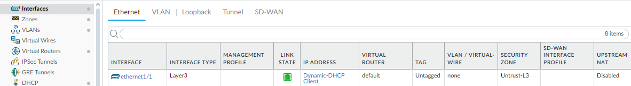
In Ethernet 1/1
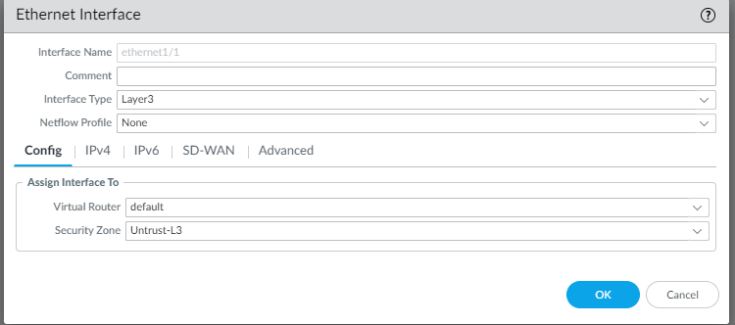
Then enter Ipv4
You will find a little button that says DHCP Client
Click that and save.
Inside of VLANs:
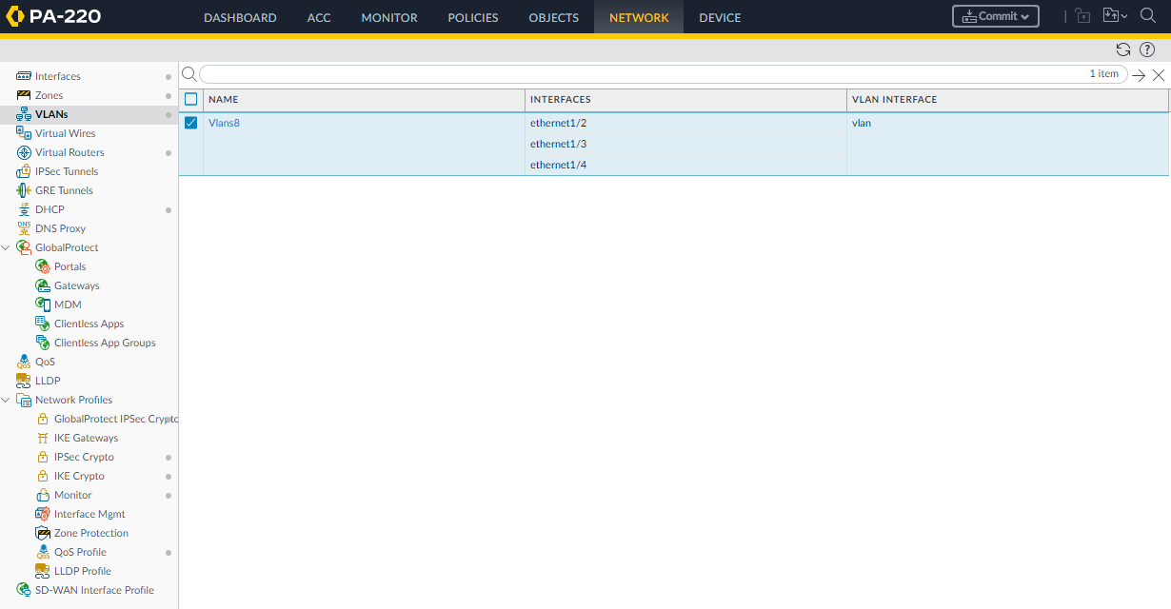
Use the Add to create a VLAN for home network use.
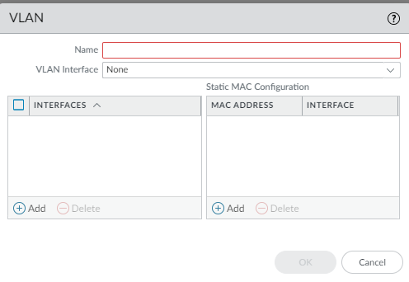
In the name box you should Name it whatever is convenient. I named mine, Vlan8.
Select “vlan” as your VLAN Interface. (default vlan)
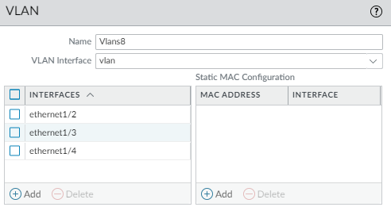
Then confirm by pressing OK.
Making A DHCP Sever inside of the firewall.
Navigation: Go to networks -> DHCP -> DHCP Server (at the top inside the window)
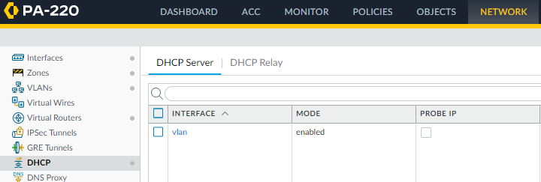
Down at the Bottom, Click Add.
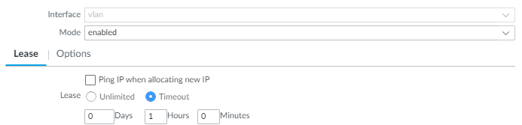
Select vlan as your interface.
Use enabled instead of auto to force it to run.
And lastly Select timeout and set it to an hour so you don get a buildup of devices.
Now click over to options and copy these for initial config.
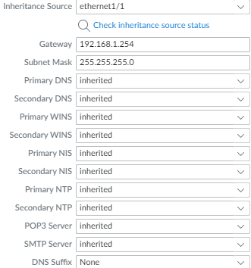
Configure L2 Ports and Vlan Object
Navigation: Network -> Interfaces -> Ethernet (2,3,4)
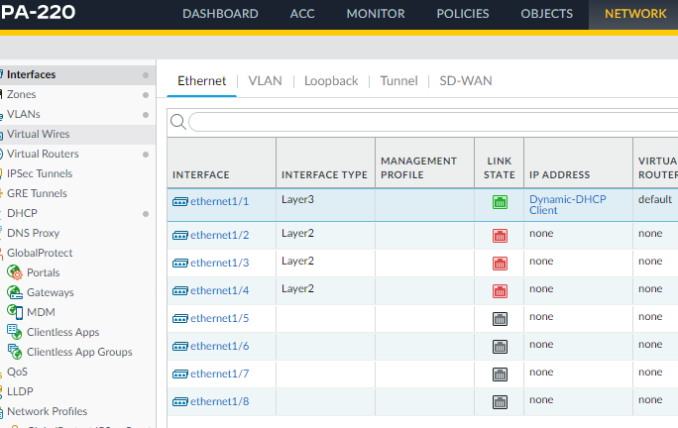
And by clicking on Ethernet ½ you can enter its config.
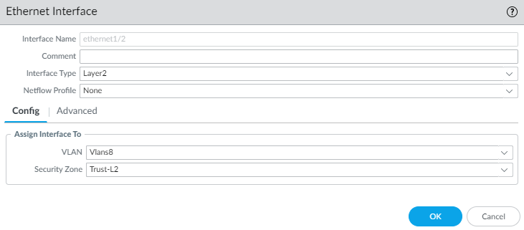
Use your configured vlan and select interface type as Layer 2.
Any ports you intend to actively use should have this process completed before use, otherwise they will not function properly.
Now to configure your VLAN interface
Navigation: Network -> Interfaces -> VLAN
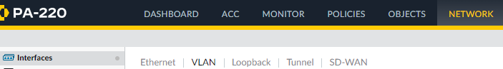
Set The Vlan to What you named it before, again. And use the default Virtual Router, then set this to L3 Trust as this is going to be an internal Vlan. (trust inside traffic)
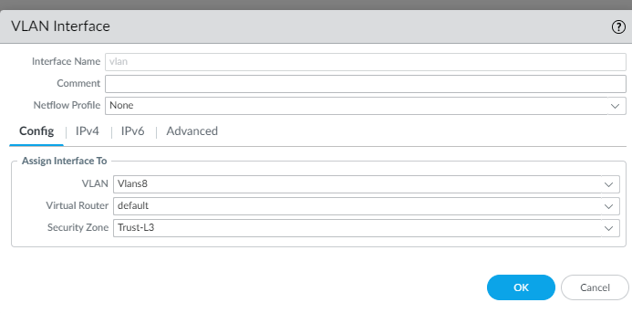
Navigate to the Ipv4 Tab and enter this Ip: 192.168.1.254
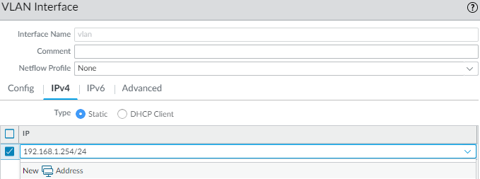
Now you have a configured Vlan with a IP that we will use later… on to security profiles.

Define a Security Profile Group
Navigation: Objects -> Security Profile Groups
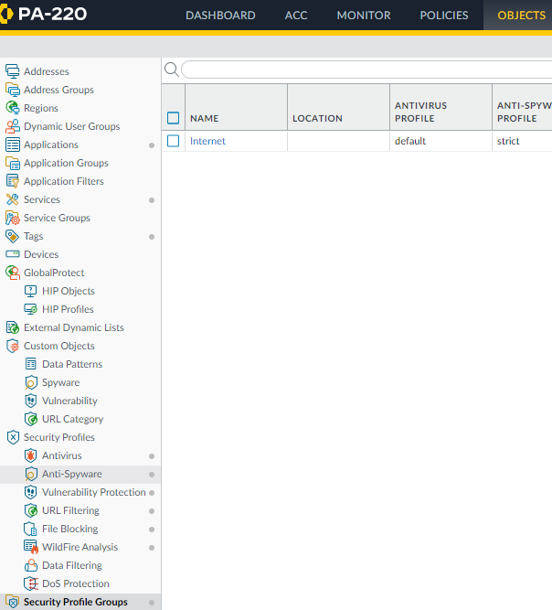
For creating a secure network and making use of the firewalls capabilities we will be using this config.
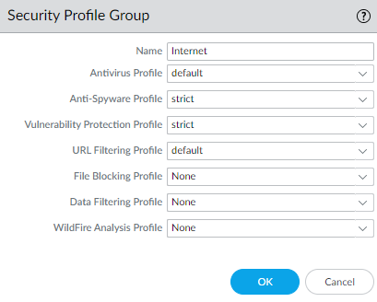

Configuring Outbound Internet Security Policies
Navigation: Policies -> Security then click add
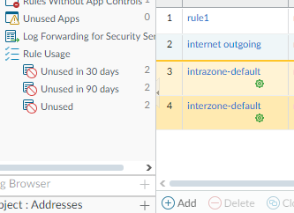
Now add a Name and Description
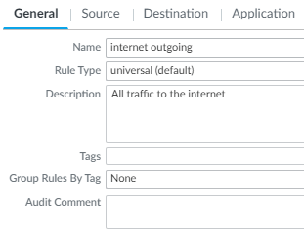
Set your souce zone to Trust-L3
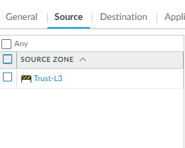
And your Destination zone to Untrust-L3
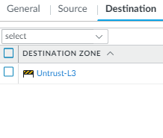
And then set these Settings To “Actions”
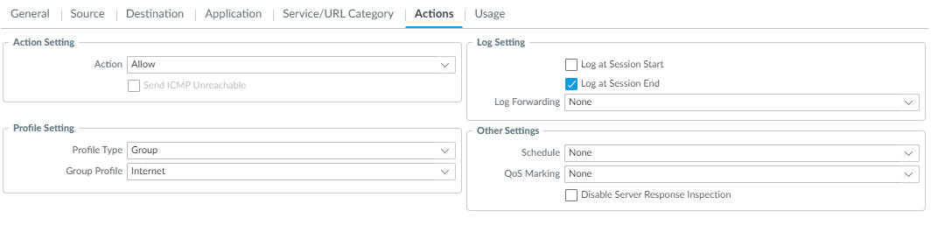
And you are done with Security Policies, Lets move onto Internet NAT policies.
Navigation: Policies -> NAT
Lets set up an internet Outgoing Nat Policy
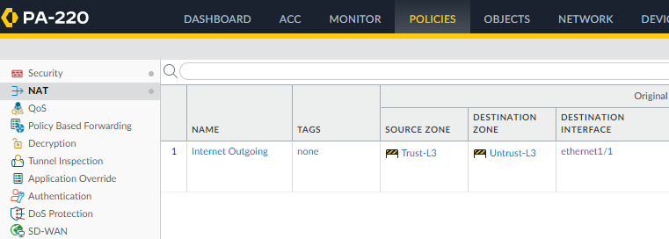

In General we can name the Policy
Add a Description and select Ipv4 if not already selected.
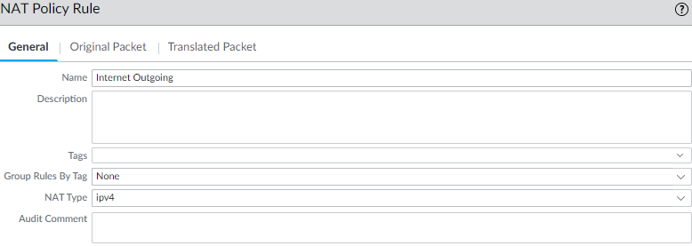
Add Trust L3 to your Original packet area (inside your network)
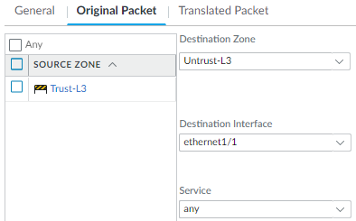
And configure your Translated Packet Section to look like this.
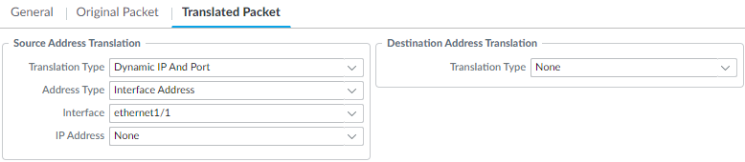
Press OK to save this change and now we are going to configure MGMT IP

Configure the MGMT IP
Navigation: Device -> Setup -> Interface Settings
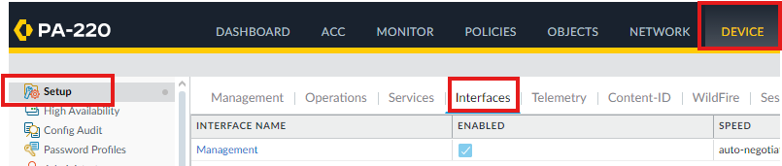

This is where you can change the management IP and subnet and configure it to work for you. The original 192.168.1.1 works in my situation so that is what I will be continuing with.
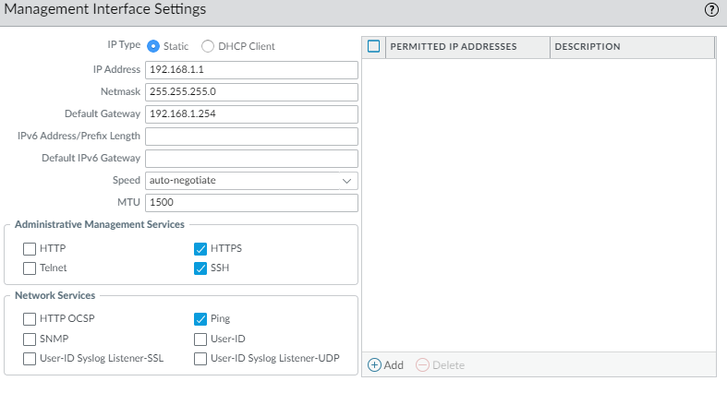

COMMIT CHANGES!!!
Without committing changes you wont have your configuration updated and your work will delete upon restart of your firewall.
This is the final saving steps.
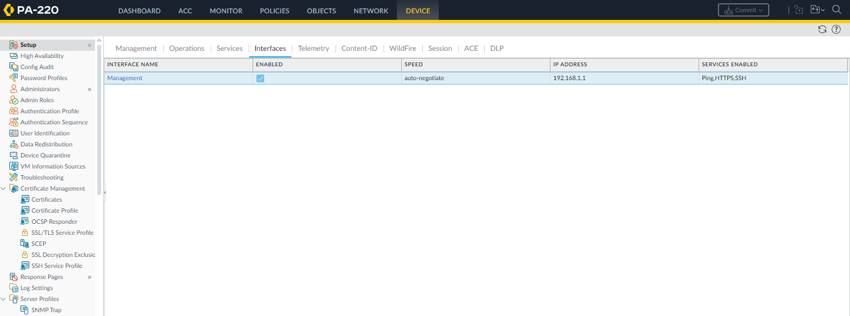
Now commit your changes.
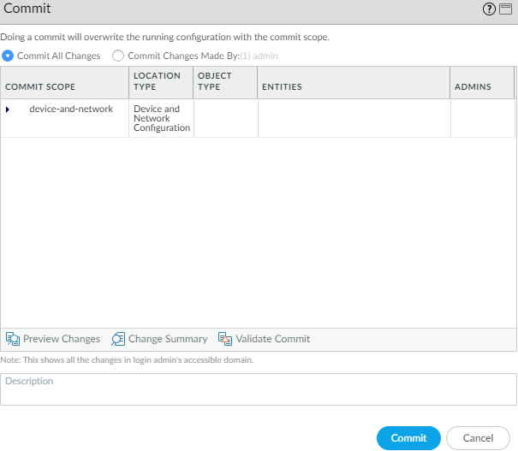
If you have Virtual Wire issues, try deleting the default virtual wire. It fixed the problem in most cases.
Good luck with your continued Firewall Configuration!

